
Common Security Module
UPT Backwards Compatible Application Design

Version No: 1.0
Last Modified: 1/02/2009

Author : Vijay Parmar
Team : Common Security Module
Purchase Order # 34552
Client : National Cancer Institute - Center for Bioinformatics,
National Institutes of Health,
US Department of Health and Human Services

Document History

Document Location
The most current version of this document is located in CVS under security/docs/CSM 4.2/development/design.

Revision History
Version Number | Revision Date | Author | Summary of Changes
0.1 | 12/29/2008 | Vijay Parmar | Initial Draft
0.2 | 1/05/2009 | Vijay Parmar | Added Diagrams
 |  |  | .

Review
Name | Team/Role | Version | Date Reviewed | Reviewer Comments

Related Documents
More information can be found in the following related CSM documents:

Document Name

Table of Contents

1. Introduction 3
1.1 Problem Scenario 4
1.2 Scope 4
2. Requirement Analysis 5
2.1 Requirements 5
2.1.1 Business Requirements 5
2.1.2 Technical Requirements 5
2.2 Assumptions 5
2.3 Dependencies 5
2.4 Known Issues or Future Considerations 5
3. Detail Design 6
3.1 Overview 6
3.2 Components of UPTEAR Application 6
3.2.1 Login and Forwarding Web Module 6
3.2.2 Updated version of UPT 3.1 7
3.2.3 Updated version of UPT 3.2 7
3.2.4 Updated version of UPT 4.0 8
3.2.5 UPT 4.1 8
As shown in Figure 1, the UPTEAR application consists of web (module) application for the UPT v4.1. The UPT v4.1 web application is packaged in the UPTEAR.ear as one of the web modules. The UPT v4.1 is modified and repackaged as a web application .WAR file. 8
3.3 Overall Workflow and Interaction between the Web Modules 8
3.3.1 Workflow 8
3.3.2 Interaction between web modules 8
3.3.3 Session Attribute 9
3.4 Configuration 9
3.4.1 Overview 9
3.4.2 Structure of the UPTEAR 10
3.5 Deployment 10
4. Unit Testing 12
4.1 JUnit Test Cases 12
4.2 Test Case Scenarios 12

Introduction

The Common Security Module (CSM) was chartered to provide a comprehensive solution to common security objectives, so not all development teams need to create their own security methodology. The User Provisioning Tool web application is the User Interface available to provision User and manage Authorization Policy for any particular application.

Problem Scenario

The CSM API and CSM User Provisioning Tool have been widely adopted by various applications within NCI CBIIT and other non-NCI applications. Since its inception, the CSM has been enhanced to provide various new features and has been released in many versions. Various applications have adopted different versions of CSM/UPT. To make use of the new features of CSM, the application has to upgrade to the latest version of CSM available at the time.

CSM UPT has been hosted commonly for applications to provision User security. The common hosting is done for the DEV, QA, STAGE and PROD tiers. Currently the CSM UPT v3.1, CSM UPT v3.2 and CSM UPT v4.0 are commonly hosted on the four tiers. It has become a maintenance issue for the Systems Team to support multiple versions of CSM UPT on various tiers. With upcoming releases of CSM UPT, it is becoming a huge challenge to get existing applications to upgrade to later versions of CSM so older versions can be deprecated.

To avoid this hosting of multiple versions and a constant race to upgrading to later versions CSM, it is desired to have a new CSM UPT that is backwards compatible and allows User provisioning into existing and previous versions of the CSM Schema. More specifically, it is desired to have a single instance of UPT to be hosted on each tier that allows user provisioning on CSM v3.1, CSM v3.2, CSM v4.0 and CSM v4.1. It is also required that the new UPT can be easily extended to incorporate latest CSM versions.

Scope

This document details the design for the new UPT that is a backwards compatible application with previous versions of UPT. This document provides details on the design on the new UPT application. It goes over the Login and Forwarding Web module along with UPT web modules. The description of design, implementation of existing UPT 3.1, UPT 3.2, UPT 4.0 and UPT 4.1 is beyond the scope of this document.

Requirement Analysis

Requirements

Business Requirements
- Provide a new UPT installation that allows provisioning users on multiple CSM Schema versions

- Easy to incorporate future versions of UPT

Technical Requirements

- Seamless integration of UPT versions 3.1, 3.2, 4.0, 4.1

The new version of UPT should allow seamless integration of the different versions of existing UPT web applications. The new UPT application should provide the Login screen that is same as existing ones available in existing UPT versions. This allows users to work with familiar screens and ease of use.

- Auto detect UPT version based on the User login

The Users of UPT application may or may not know the version of CSM Schema or version of the UPT that is being used. It is required to detect version of the CSM Schema based on the Login ID, Password and Application Context provided by the user.

- The solution should be extensible to allow incorporating future versions of UPT with minimal changes to source code.

- Provide an easy to configure and deployment procedure for the new approach

Assumptions
- The CSM schema for various versions could be on separate database servers.
- The UPT web applications will be installed in one container and tomcat clustering is not used.
- Only one application context name is used to for Authorization Policy provisioning per installation container.

Dependencies

- Current Technology Stack

Known Issues or Future Considerations

- The new UPTEAR application will not support Tomcat 5.0.28 as it will be packaged as an J2EE EAR that cannot be deployed on Tomcat 5.0.28 in the Current Technology Stack.

Detail Design

Overview

This following section describes the solution designed for the backwards compatible UPT application.

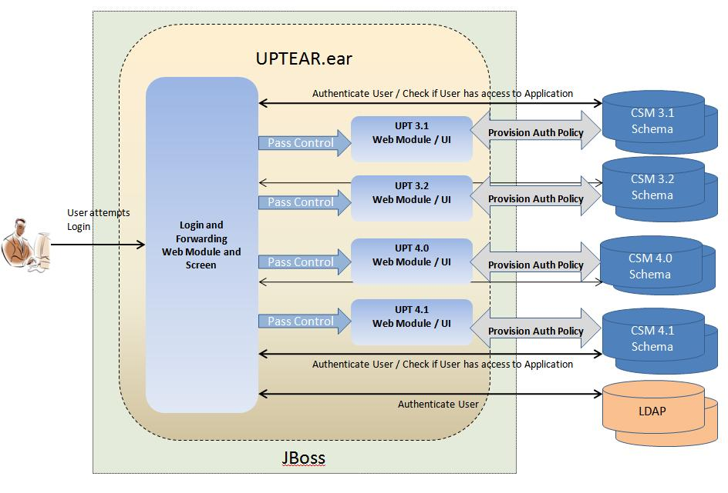
Figure 1: CGMM Design

The above diagram demonstrates the components of the new UPTEAR application and their interactions at a high level. As shown in the figure 1, the new application UPTEAR is an Enterprise Application packaged as UPTEAR.ear file. The components of the UPTEAR.ear (EAR) are mentioned in the following section. The UPTEAR application interacts with the various CSM Schema versions to provisioning authorization policy for particular applications. The UPTEAR application authenticates users against the configured Credential Providers such as LDAP and RDBMS.

Components of UPTEAR Application

Login and Forwarding Web Module

The Login and Forwarding Web Module, as the name indicates, provides a Login user interface to authenticate users. It provides the user with a Login screen with three input boxes: Login ID, Password and Application Context Name (same as existing UPT versions). As the user attempts to login by providing the three details, this module attempts to authenticate the users Login ID and Password against configured JAAS Login Modules (LDAP or RDBMS). Once the user is authenticated, the Login module obtains CSM AuthoriztionManager for the Application Context Name. The module checks permission to see if the User has access privilege for the given Application Context Name. If the User is authenticated and has appropriate access privileges to the application context, then the Login and Forwarding Module passes control and forwards the request to the respective version of the UPT web module.

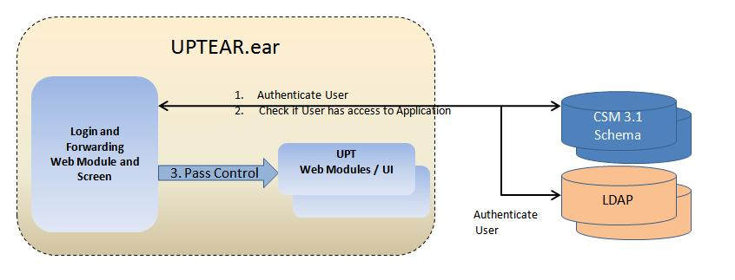
Figure 2

Updated version of UPT 3.1

As shown in Figure 1, the UPTEAR application consists of a web module or web application for the UPT v3.1. The UPT v3.1 web application is packaged in the UPTEAR.ear as one of the web modules. The UPT v3.1 is modified and repackaged as a web application .WAR file.

The UPT 3.1 will be modified to upgrade to the current technology stack. The CSM API JAR file will be recreated using the current technology if necessary.

Updated version of UPT 3.2

As shown in Figure 1, the UPTEAR application consists of a web module or web application for the UPT v3.2. The UPT v3.2 web application is packaged in the UPTEAR.ear as one of the web modules. The UPT v3.2 is modified and repackaged as a web application .WAR file.

The UPT 3.2 will be modified to upgrade to the current technology stack. The CSM API JAR file will be recreated using the current technology if necessary.

Updated version of UPT 4.0

As shown in Figure 1, the UPTEAR application consists of a web module or web application for the UPT v4.0. The UPT v4.0 web application is packaged in the UPTEAR.ear as one of the web modules. The UPT v4.0 is modified and repackaged as a web application .WAR file.

If necessary, the UPT 4.0 will be modified to upgrade to the current technology stack.

UPT 4.1

As shown in Figure 1, the UPTEAR application consists of web (module) application for the UPT v4.1. The UPT v4.1 web application is packaged in the UPTEAR.ear as one of the web modules. The UPT v4.1 is modified and repackaged as a web application .WAR file.

Overall Workflow and Interaction between the Web Modules

Workflow

The overall workflow of the UPTEAR application is as follows
      - The User attempts to Login to UPTEAR application by providing the Login ID, Password and Application Context Name.
      - The Login /Forwarding Web module attempts to authenticate the user against the configured JAAS Login Modules.
      - Once the user is authenticated, the Login Web Module obtains CSM AuthorizationManager for the Application Context Name based on CSM schema that has the application context provisioned already and the user has appropriate access permissions.
      - If the User has access permissions, the Login Module determines the version of CSM Schema and UPT.
      - The Login web module populates the HTTP Request object with attribute ‘CSM_USER_ID’ and also sets it in the session object.
      - The Login/Forwarding Module then forwards the HTTP Request to the appropriate UPT web application context.
      - The user is shown the user home page by the corresponding UPT web application.
      - The particular UPT web application sets the Users ID in session.
      - The user can proceed to provision authorization policy.

Interaction between web modules

The Login / Forwarding Web application module and individual UPT web applications in the UPT Enterprise Application interact at the time of passing control from Login Web application to a UPT web application or vice versa. The interaction happens under following scenarios.

User is not logged in and User attempts login

If the user is not logged in and the user attempts login, then the interactions between the modules occur as described in the overall workflow in previous section.

User was logged in and Session times out

If the session times out on an already logged user, the particular UPT web application will redirect the user to the Login Screen of the Login/Forwarding Web application. The UPT web application will also remove the current CSM User ID from the session and invalid the session. The interaction continues as described in the overall workflow.

User is logged in and User tries to access different UPT 3.X or 4.X version of web application

If the user is already logged in to a UPT web application and the user attempts to access another UPT web application context then the target UPT web application will redirect the user to the Login screen of the Login/Forwarding web application module.

Session Attribute

The passing of control from the Login/Forwarding Web application to the particular version of UPT web application is possible only when a user is authenticated and authorized to access the Application specified in the Login screen.

The Login/Forwarding web application populates the Users CSM Login ID in the request before forwarding it to the particular UPT instance/context. This UPT web application is the same version to which the authorizing CSM Application’s Schema belongs to.

Session Attribute Name | Information
CSM_USER_ID | User’s CSM Login ID

Configuration

Overview

The configurations for the UPTEAR application are the following:

- The UPTEAR configuration file: uptear-properties.xml
  - List of versions of UPT web applications to be installed/activated for this UPTEAR application
- Login-config – Entry for LoginModule(s) for CSM authentication.
- JNDI Data source – Pointing to the CSM Schema for different versions of UPT web application.

Structure of the UPTEAR
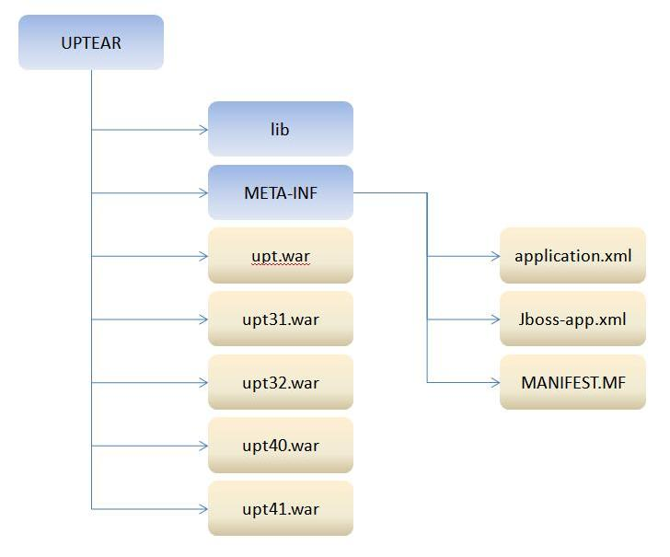
Figure 3: Structure of UPTEAR application

As shown in figure 3, the UPTEAR application consists of five web application modules.
- Upt.war is for the Login and Forwarding web application module.
- Upt31.war, upt32.war, upt40.war and upt41.war

Deployment

The following artifacts are involved to install and deploy the UPTEAR application:
- UPTEAR.ear application file.
- The uptear-properties.xml configuration file.
- The JBoss login-config.xml
- The *-ds.xml to configure the datasource

Unit Testing

JUnit Test Cases
The solution is for Enterprise Application with Web applications only. Hence automated HTTPUnits/JUnit will not be available.

Integration tests will be performed and provided for flows and exceptions paths.

Test Case Scenarios
The test case scenarios will be developed in conjunction with the QA Team. Based on the initial design the overall test scenarios are as mentioned below. Note that based on data each of these scenarios can have multiple test cases

  - Testing Login to UPT
  - Testing Login and redirection to appropriate UPT context (version)
  - Functional validation for each UPT version use cases.
  - Testing Configuration and deployment of the UPTEAR.ear.

